Course: COSC457.101 – Database Management Systems

Instructor: Leon Bernard

Room: YR-304

February 27, 2020 7:00 pm

**Database Model**

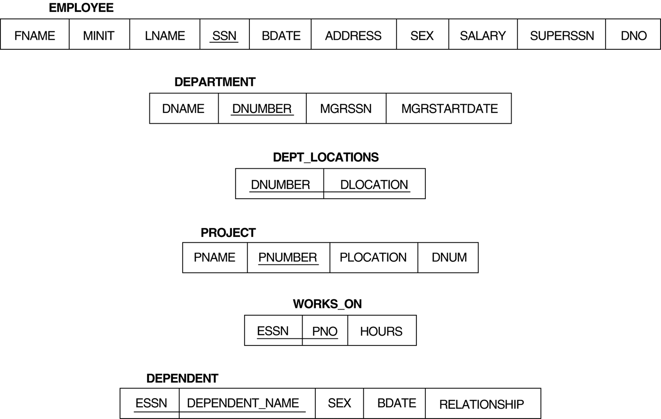

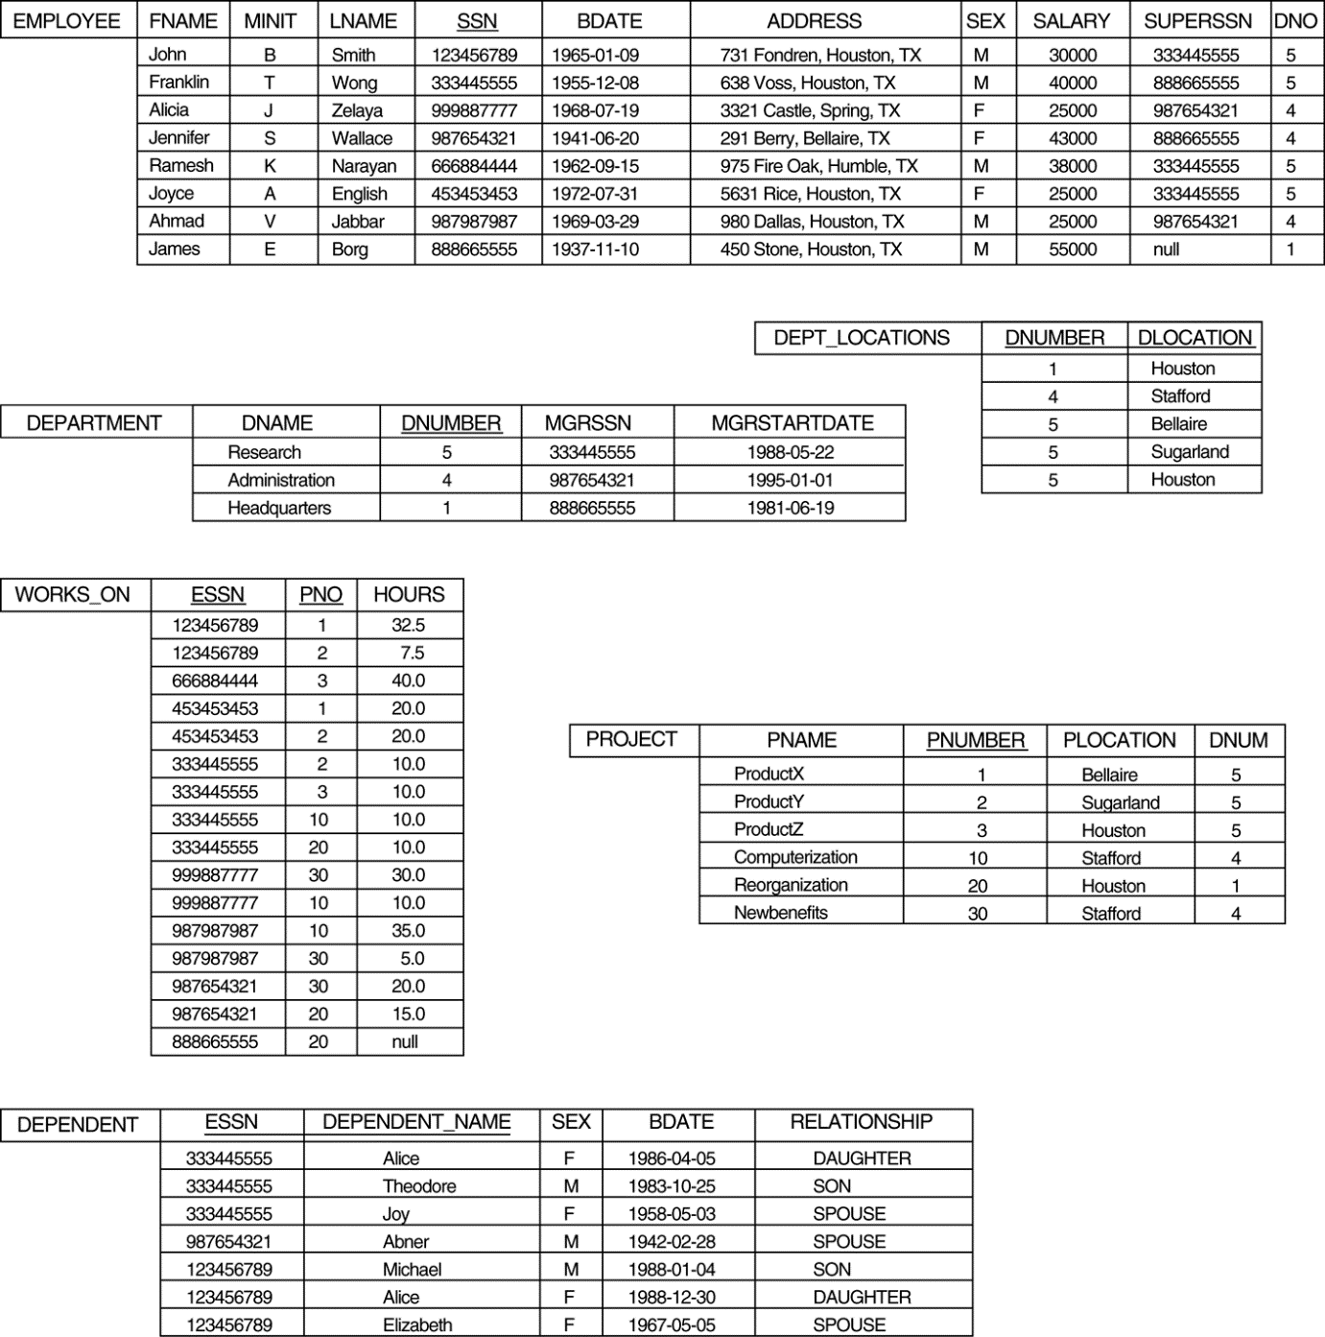

**SQL statements**

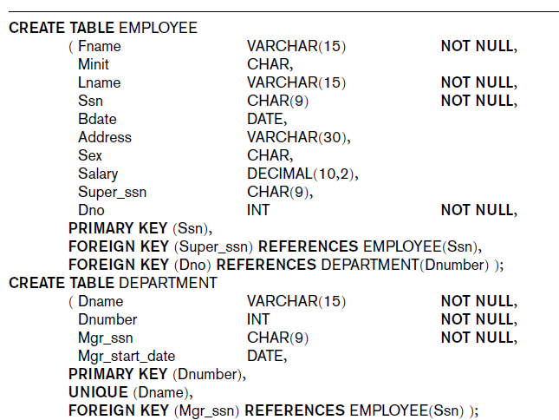

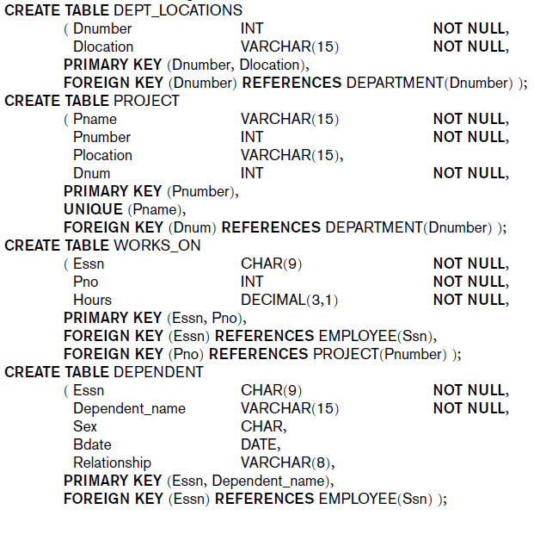

**Questions**

1. Retrieve the list of employees who worked for department 5.
2. Retrieve the list of employees without dependents.
3. Retrieve the maximum salary of male employees.
4. Retrieve the average salary of female employees.
5. Increase female employees’ salary by 10% then rerun the query from Question 4.
6. Retrieve the total number of hours work by each employee per department controlling the project.
7. Add columns TotalHours and NumOfEmployee to Project table
8. Create a view on Employee table which only display first name, last name and department umber
9. Create the following functions
   1. A function which return the number of employees who worked on a specific project. The function input parameter is pnumber (integer)
   2. A function which return the sum of hours worked on a specific project. The function input parameter is pnumber (integer)
10. Create a procedure which computes the average number of hours worked on each project for a department. The procedure input parameter should be department number
11. Create an trigger on WORKS_ON table which updates Project’s TotalHours and NumOfEmployee columns using the functions from previous question